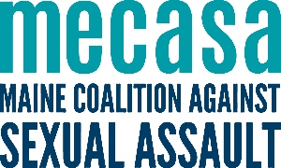
Maine’s Sexual Assault Support Centers

AMHC Sexual Assault Services
(Aroostook, Washington, Hancock)
207-493-3361

Sexual Assault Support Services
of Midcoast Maine (SASSMM)
(Eastern Cumberland, Sagadahoc, Knox, Waldo, Lincoln)
207-725-2181

Immigrant Resource Center
of Maine (IRCM)
(Culturally Specific Services)
207-753-0061

Sexual Assault Prevention
& Response Services (SAPARS)
(Franklin, Oxford, Androscoggin)
207-784-5272

Sexual Assault Crisis and
Support Center (SAC&SC)
(Kennebec, Somerset)
207-377-1010

Sexual Assault Response Services
of Southern Maine (SARSSM)
(Cumberland, York)
207-828-1035

Rape Response Services (RRS)
(Piscataquis, Penobscot)
207-973-3595

